RAILWAY RESERVATION SYSTEM

Project report

Under the guidance of

Mr. Thammi Reddy Sir

By

S.Swaroop



**Department of computer science and engineering**

**GITAM INSTITUTE OF TECHNOLOGY**

**GITAM (DEEMED TO BE UNIVERSITY)**

**(Estd. u/s 3 of the UGC Act, 1956, NAAC Accredited With A+ Grade)**

**Visakhapatnam-530045**

**SEPTEMBER**

**INDIAN RAILWAY RESERVATION SYSTEM**

Aim:

The railway reservation system facilitates the passengers to enquire about the trains available on the basis of source and destination, booking and cancellation of tickets, enquire about the status of the booked ticket, etc.

The aim of case study is to design and develop a database maintaining the records of different trains, train status, and passengers. The record of train includes its number, name, source, destination, and days on which it is available, whereas record of train status includes dates for which tickets can be booked, total number of seats available, and number of seats already booked.

ABSTRACT:

The Railway Reservation System facilitates the passengers to enquire about the trains available on the basis of source and destination, Booking and Cancellation of tickets, enquire about the status of the booked ticket, etc. The aim of case study is to design and develop a database maintaining the records of different trains, train status, and passengers. This project contains Introduction to the Railways reservation system .It is the computerized system of reserving the seats of train seats in advanced. It is mainly used for long route. On-line reservation has made the process for the reservation of seats very much easier than ever before.

**INTRODUCTION:**

Database is an organized collection of data. The data is typically organized to model aspects of reality in a way that supports processes requiring information. A DBMS makes it possible for end users to create, read, update and delete data in a database. The DBMS essentially serves as an interface between the database and end users or application programs, ensuring that data is consistently organized and remains easily accessible. The DBMS manages three important things: the data, the database engine that allows data to be accessed, locked and modified and the database schema, which defines the database’s logical structure. These three foundational elements help provide concurrency, security, data integrity and uniform administration procedures. The DBMS can offer both logical and physical data independence. That means it can protect users and applications from needing to know where data is stored or having to be concerned about changes to the physical structure of data.

The main purpose of maintaining database for Railway Reservation System is to reduce the manual errors involved in the booking and cancelling of tickets and make it convenient for the customers and providers to maintain the data about their customers and also about the seats available at them.Due to automation many loopholes that exist in the manual maintenance of the records can be removed. The speed of obtaining and processing the data will be fast. For future expansion the proposed system can be web enabled so that clients can make various enquiries about trains between stations. Due to this, sometimes a lot of problems occur and they are facing many disputes with customers. To solve the above problem, we design a data base which includes customer details, availability of seats in trains, no of trains and their details

**Objective Of This Project:**

1.give structural design to railway system

2.The project provides functionality and flexibility to railway system such that one can operate that system easily and efficiently.

3.This project also provides a complete set of solutions for some common and specific are as of work in the railways

**RAILWAY MANGEMENT SYSTEM:**

Railway management System is the computerized system of reserving the seats of train seats in advanced . It is mainly used for long root . On-line reservation has made the process for the reservation of seats very much easier than ever before. In our country India, there are number of counters for the reservation of the seat sand one can easily make reservations and get tickets. Almost all of the manual reservations centre have been converted into computerized reservation centers, which providebooking and reservation of tickets from one station to another.

**PROJECT DESCRIPTION:**

This project is about creating the database about Railway Reservation System. The railway reservation system facilitates the passengers to enquire about the trains available on the basis of source and destination, booking and cancellation of tickets, enquire about the status of the booked ticket, etc. The aim of case study is to design and develop a database maintaining the records of different trains, train status, and passengers. The record of train includes its number, name, source, destination, and days on which it is available, whereas record of train status includes dates for which tickets can be booked, total number of seats available, and number of seats already booked.

A fare table is already there so that passengers can know the specific price of their ticket. And as it is stored there the amount cannot wrong.

Reduce the possibility to make mistake: Due to excessive amount of work the employers tend to do mistakes by manual form. Here the chance of mistake is minimum.

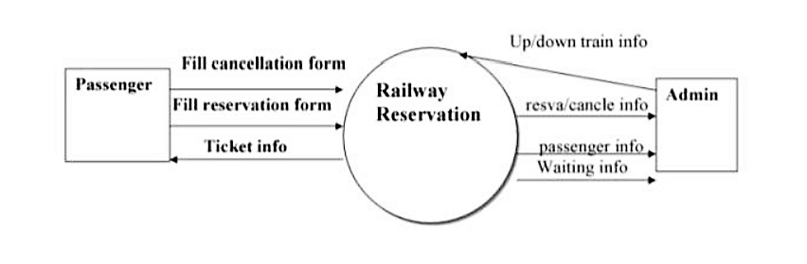

ER DIAGRAM:

An entity-relationship diagram (ERD) is crucial to creating a good database design. It is used as a high-level logical data model, which is useful in developing a conceptual design for databases.

An entity is a real-world item or concept that exists on its own. Entities are equivalent to database tables in a relational database, with each row of the table representing an instance of that entity.

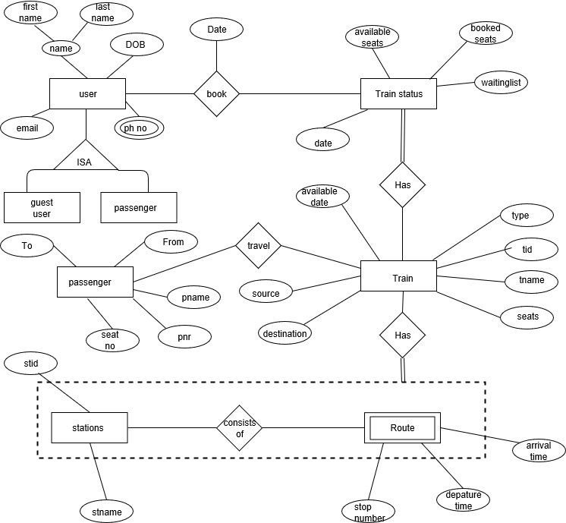

Types of Attributes:

* **Simple attribute** − Simple attributes are atomic values, which cannot be divided further. For example, a student's phone number is an atomic value of 10 digits.
* **Composite attribute** − Composite attributes are made of more than one simple attribute. For example, a student's complete name may have first_name and last_name.
* **Derived attribute** − Derived attributes are the attributes that do not exist in the physical database, but their values are derived from other attributes present in the database. For example, average_salary in a department should not be saved directly in the database, instead it can be derived. For another example, age can be derived from data_of_birth.
* **Single-value attribute** − Single-value attributes contain single value. For example − Social_Security_Number.
* **Multi-value attribute** − Multi-value attributes may contain more than one values. For example, a person can have more than one phone number, email_address, etc.

## **Relationship**

Relationships are represented by diamond-shaped box. Name of the relationship is written inside the diamond-box. All the entities (rectangles) participating in a relationship, are connected to it by a line.

### Participation Constraints:

* **Total Participation** − Each entity is involved in the relationship. Total participation is represented by double lines.
* **Partial participation** − Not all entities are involved in the relationship. Partial participation is represented by single lines.

DATABASE STRUCTURE:

Tables:

1)stations



2)train

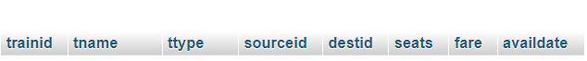

3)route



4)train status



5)reserves



**Table creation code:**

create table stations

(

stid int primary key,

    stname varchar(20)

);

create table train

(

trainid int ,

    tname varchar(30) ,

    ttype varchar(20) ,

    sourceid  int null,

    destid  int null,

    seats int,

    fare int,

    availdate varchar(20),

    primary key(trainid),

    foreign key(sourceid) references stations(stid),

    foreign key(destid) references stations(stid)

);

create table route

(

trainid int,

    stopno int not null,

    stid int,

    atime time,

    dtime time,

    primary key(trainid,stopno),

    foreign key (trainid) references train(trainid),

    foreign key (stid) references stations(stid)

);

create table trainstatus

(

trainid int,

    availdate date not null,

bseats int,

    aseats int,

    wseats int,

    primary key(trainid,availdate),

    foreign key(trainid) references train(trainid)

);

create table users

(

email varchar(20) ,

    uid int,

    passwd varchar(15),

    age int,

    gender varchar(8),

    phno varchar(10),

    city varchar(20),

    state varchar(20),

    sque varchar(20),

    sans varchar(20),

    primary key(uid,email)

);

create table reserve

(

pnr varchar(20),

    uid int,

    seatno int,

    rstatus int,

    bdate date,

    trainid int,

pname varchar(20),

    primary key(pnr),

    foreign key(trainid) references trainstatus(trainid),

    foreign key(uid) references users(uid)

);

PRIMARY KEY – A primary is a column or set of columns in a table that uniquely identifies tuples (rows) in that table.

FOREIGN KEY – Foreign keys are the columns of a table that points to the primary key of another table. They act as a cross-reference between tables

Sample Values in corresponding Tables: Values in stations table

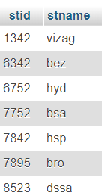

Values in train table

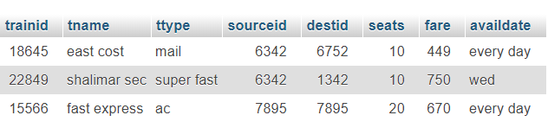

Values in route table

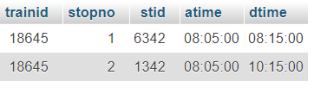

Values in train status table

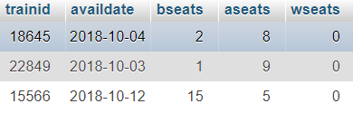

Values in users table

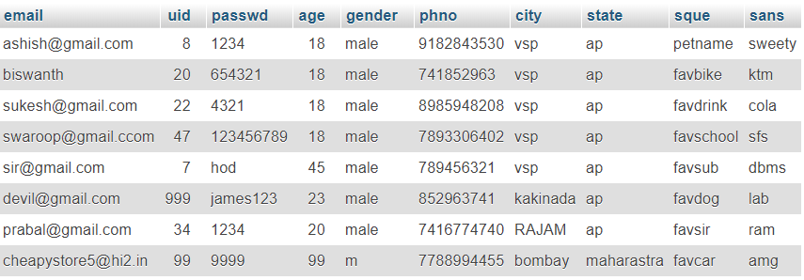

Values in reserve table

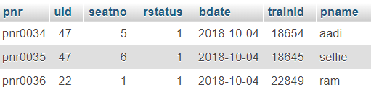

HTML AND CSS:

HTML is the language for describing the structure of Web pages. HTML gives authors the means to:

Publish online documents with headings, text, tables, lists, photos, etc.

Retrieve online information via hypertext links, at the click of a button.

Design forms for conducting transactions with remote services, for use in searching for information, making reservations, ordering products, etc.

CSS is the language for describing the presentation of Web pages, including colors, layout, and fonts. It allows one to adapt the presentation to different types of devices, such as large screens, small screens, or printers. CSS is independent of HTML and can be used with any XML-based markup language. The separation of HTML from CSS makes it easier to maintain sites, share style sheets across pages, and tailor pages to different environments. This is referred to as the separation of structure (or: content) from presentation.

Why PHP?

PHP stands for Hypertext Preprocessor and is a server-side programming language.



There are many reasons to use PHP for server side programming, firstly it is a free language with no licensing fees so the cost of using it is minimal.

A good benefit of using PHP is that it can interact with many different database languages including MySQL. We work with MySQL at Bluelinemedia since this is also a free language so it makes sense to use PHP. Both PHP and MySQL are compatible with an Apache server which is also free to license. PHP can also run on Windows, Linux and Unix servers.

Due to all these languages being free it is cheap and easy to setup and create a website using PHP.

PHP also has very good online documentation with a good framework of functions in place. This makes the language relatively easy to learn and very well supported online. There are countless forums and tutorials on various PHP methods and problems so it is usually very easy to find help if you need it.

Due to PHP being so accessible and cheap to setup there are a lot of people who know how to use the language which makes finding new employees proficient in this language less challenging.

Those are the main reasons we use PHP at Bluelinemedia.

Features of PHP

Features of PHP

It is most popular and frequently used world wide scripting language, the main reason of popularity is; It is open source and very simple.

• Simple ,Faster

• Interpreted

• Open Source

• Case Sensitive

• Simplicity

• Efficiency

• Platform Independent

• Security

• Flexibility

• Familiarity

• Error Reporting

• Loosely Typed Language

• Real-Time Access Monitoring

Simple

It is very simple and easy to use, compare to other scripting language it is very simple and easy, this is widely used all over the world.

Interpreted

It is an interpreted language, i.e. there is no need for compilation.

Faster

It is faster than other scripting language e.g. asp and jsp.

Open source means you no need to pay for use php, you can free download and use.

Platform Independent

PHP code will be run on every platform, Linux, Unix, Mac OS X, Windows.

Case Sensitive

PHP is case sensitive scripting language at time of variable declaration. In PHP, all keywords (e.g. if, else, while, echo, etc.), classes, functions, and user-defined functions are NOT case-sensitive.

Error ReportingPHP have some predefined error reporting constants to generate a warning or error notice.

Real-Time Access Monitoring

PHP provides access logging by creating the summary of recent accesses for the user.

Loosely Typed Language

PHP supports variable usage without declaring its data type. It will be taken at the time of the execution based on the type of data it has on its value.

Front end:

Login page&home page:

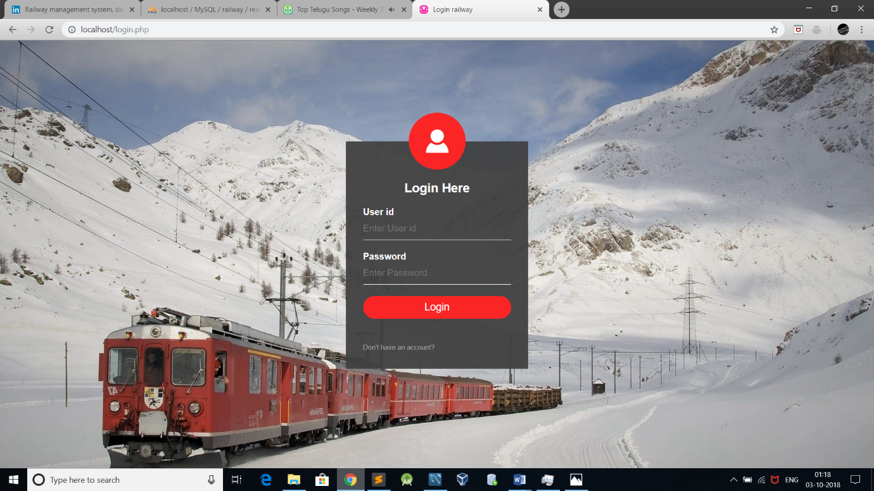

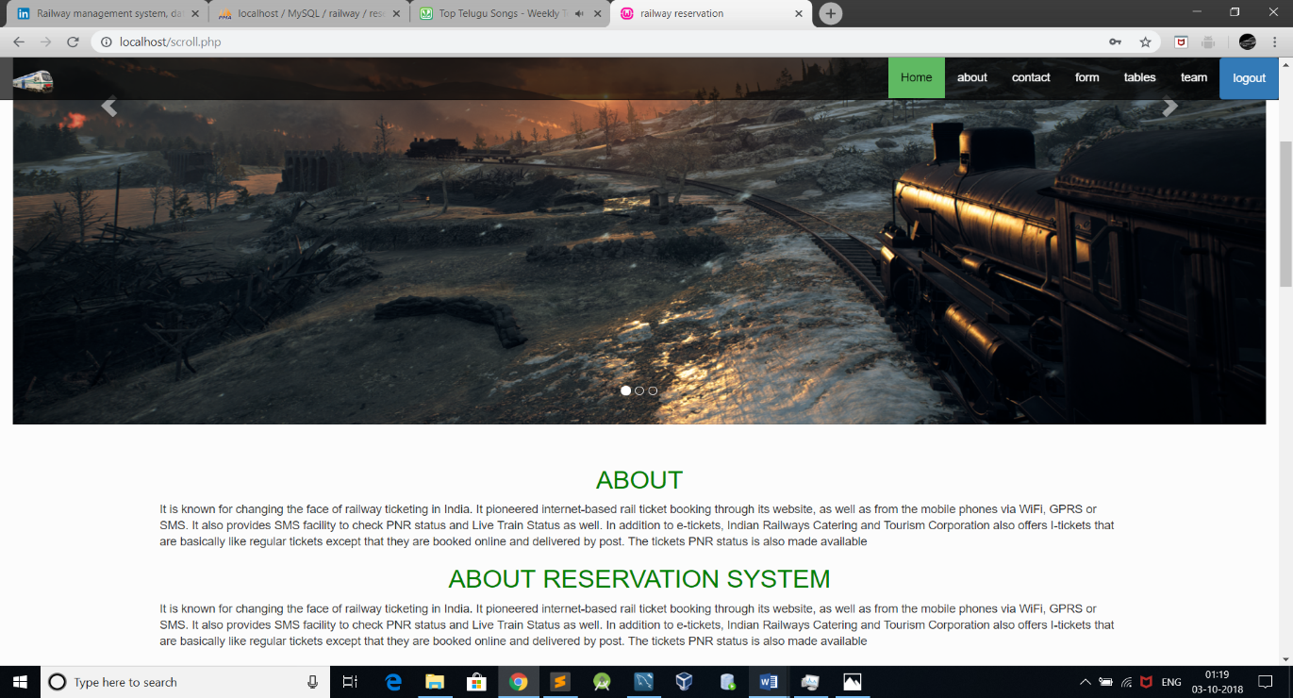

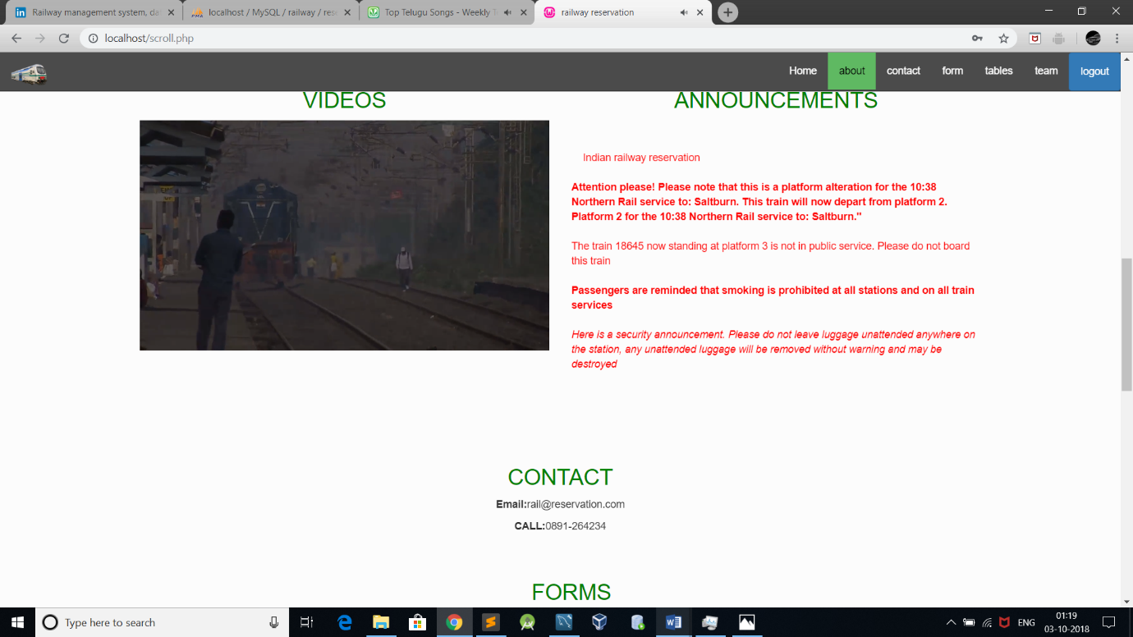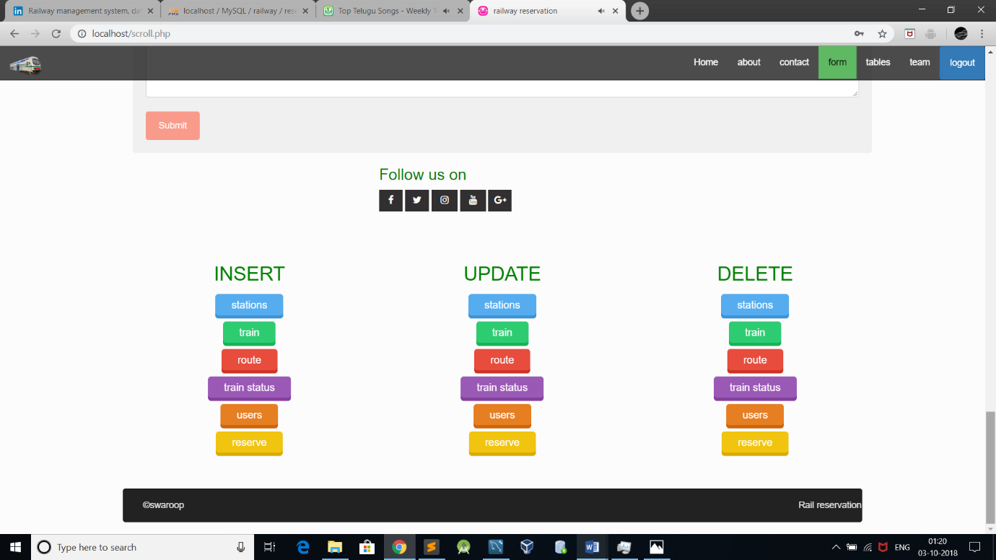

Tables output page:

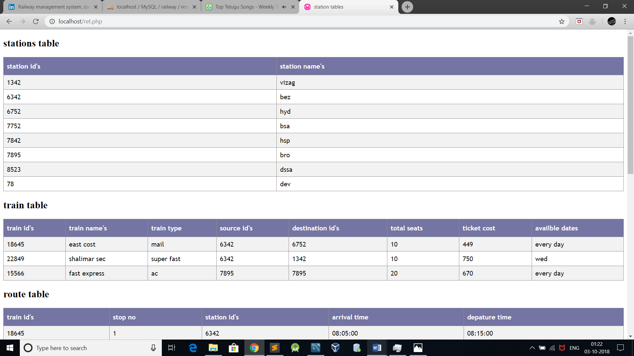

Php code retrival:

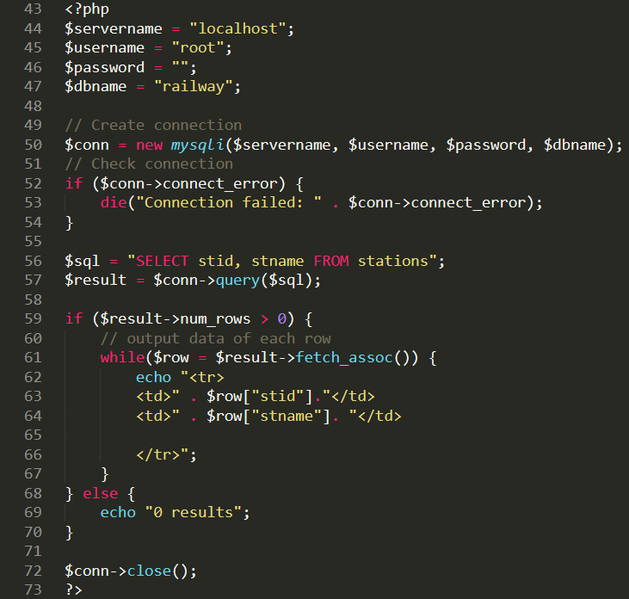

Sample update page layout:

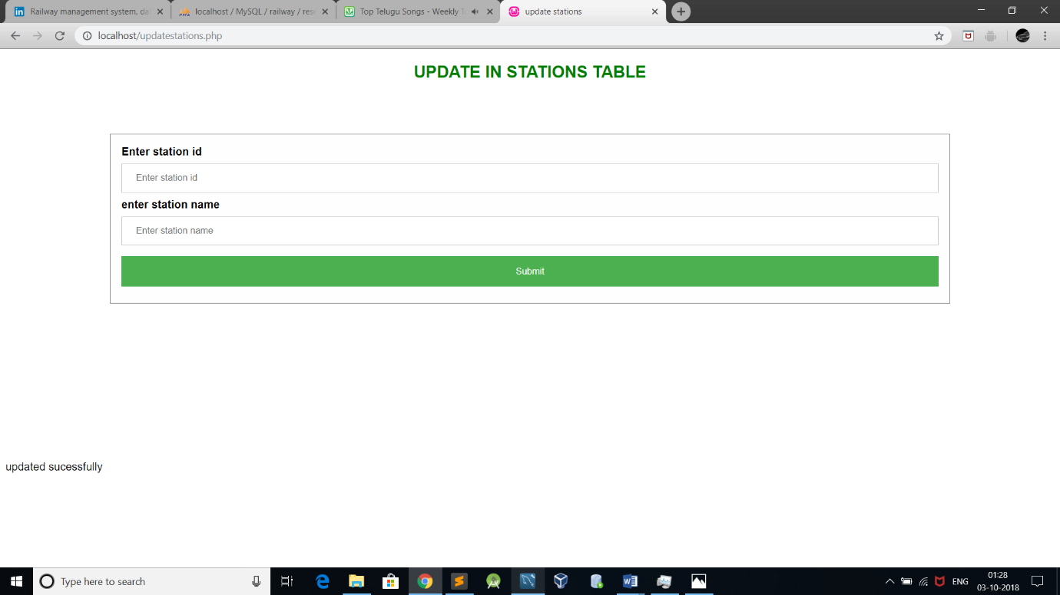  
php code for update:

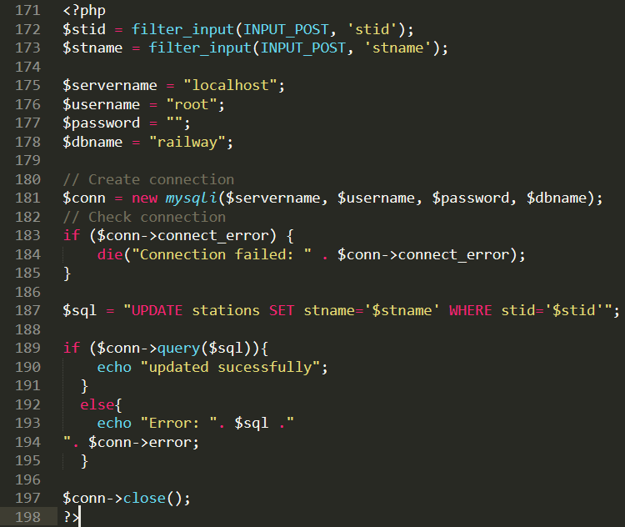

Sample insert page layout:

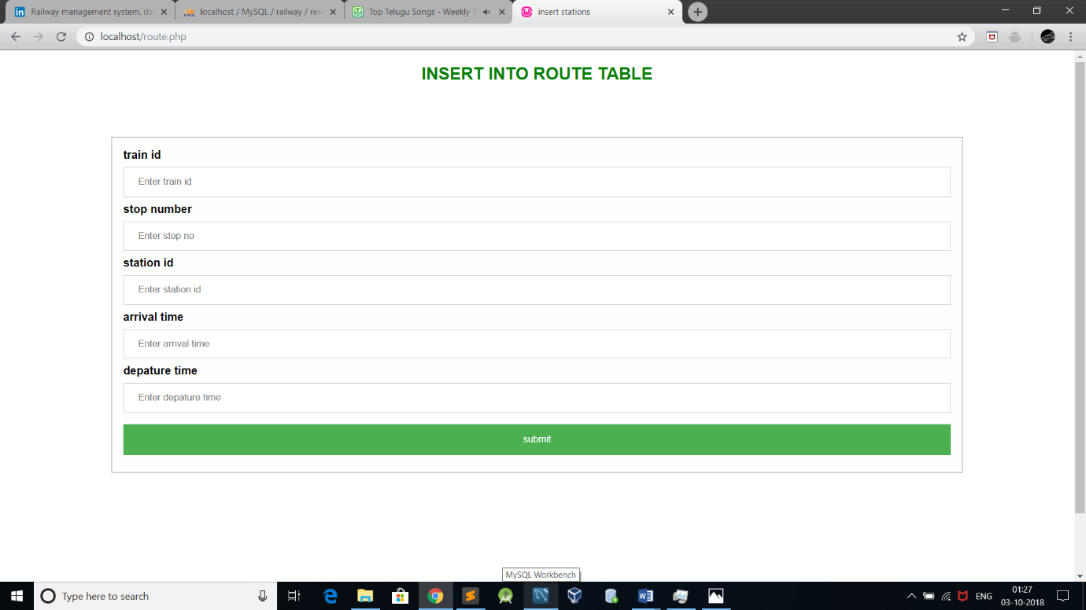

Php code for insert page:

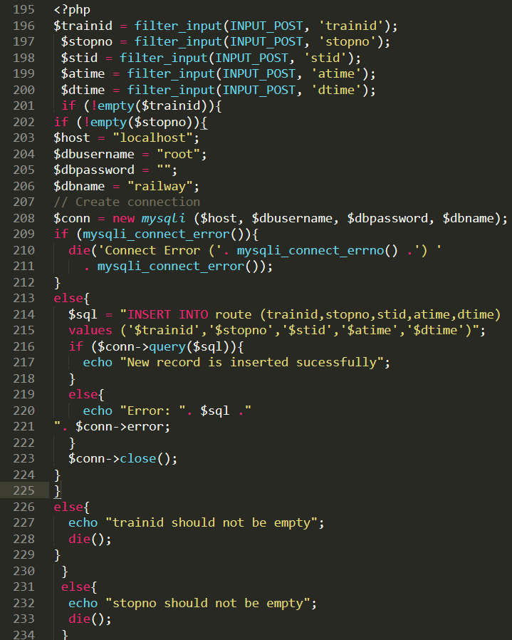

Sample delete page layout:

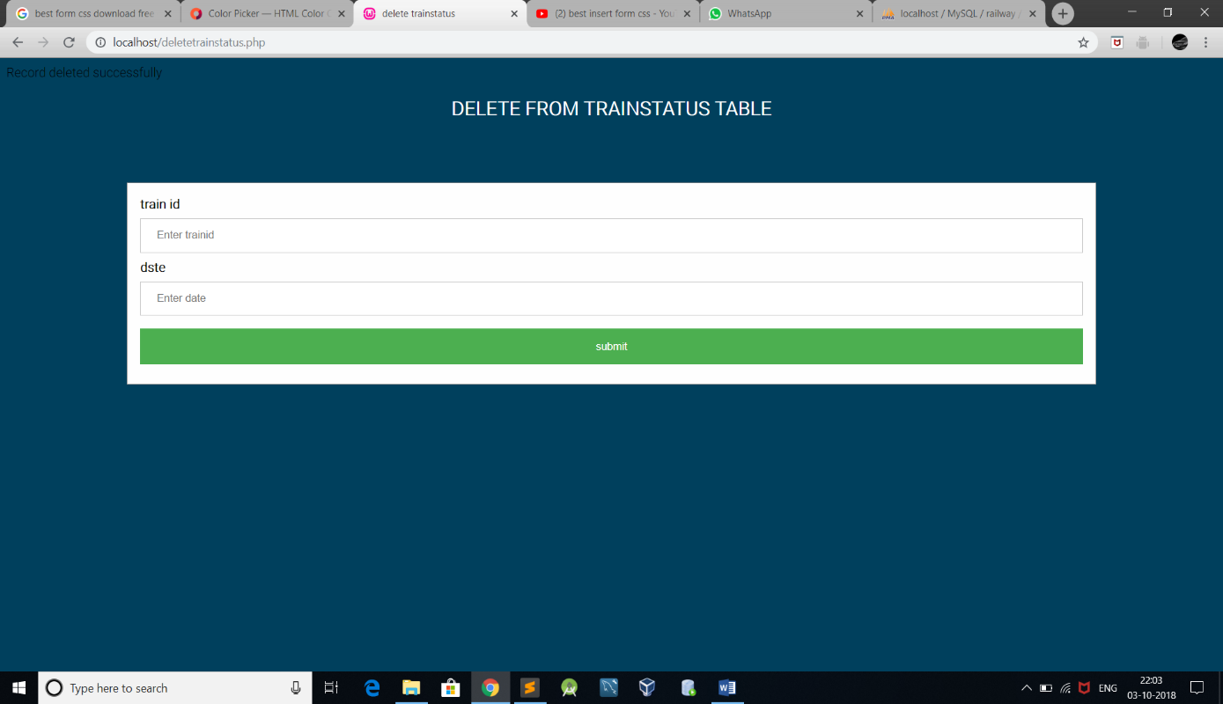

Php code:

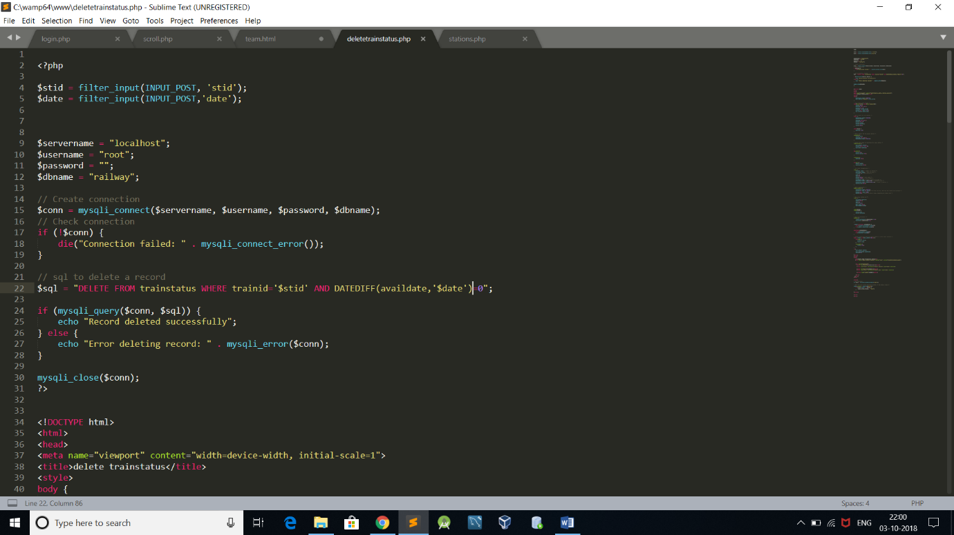

**TEAM page:**

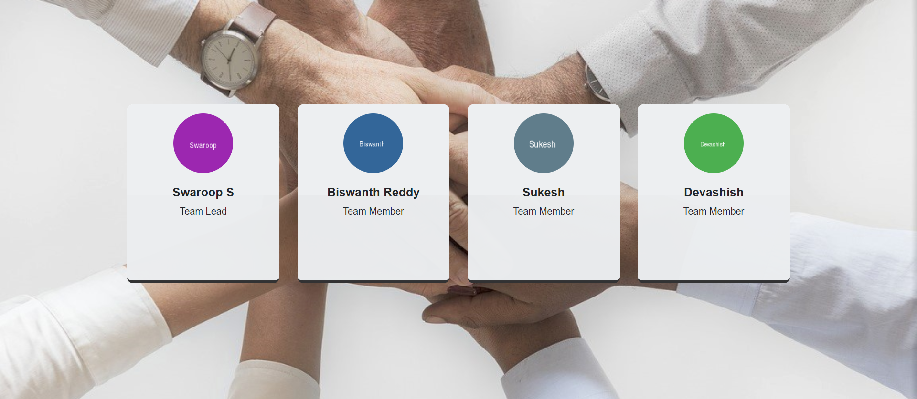

**Tools used:**

1)Mysql

2)Wamp server

3)sublime text editor

4)ER diagram online software

**Languages used:**

HTML(Hypertext Markup Language),

CSS(Cascading Style Sheets),

PHP(PHP is a recursive acronym for "PHP: Hypertext Preprocessor".),

SQL(Structured Query Language).